Lab: File Permissions in Linux
Now that you’re comfortable with basic Linux navigation, let’s dive into how to read and change file permissions.

Learning Objective
By the end of this lab, you will be able to:
- Read permissions with ls -l and decode rwxr-x---.
- Change permissions using symbolic (u/g/o + - =) and numeric (755, 644) modes with chmod.
- Explain how permissions differ for files vs directories (what execute x means on a folder).
- (Optional) Change file ownership with chown and group with chgrp (requires sudo).

Pre-Requisite
- A shell on any Linux system (local VM, WSL, or remote VM).
- No admin rights required for the core steps (optional sudo for ownership tasks).
- Basic terminal comfort: running commands and using cd.

Steps to Follow

Part A — Set Up a Safe Playground
Open a terminal and create a lab folder:
cd ~
mkdir -p perm-lab
cd perm-lab

Create some test files and folders:
echo "hello" > note.txt
echo "secret" > secrets.txt
mkdir -p data reports
touch data/raw.csv reports/summary.md

Part B — Read Permissions with ls -l
List with details:
ls -l

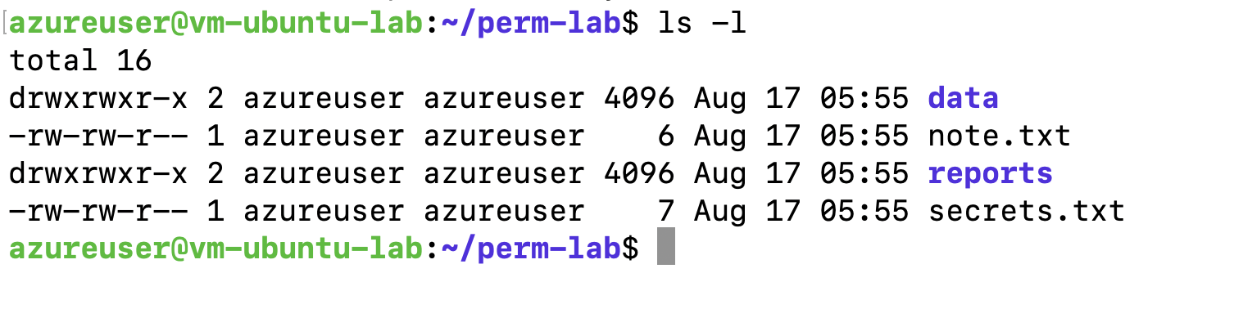
Sample output (yours will vary):

-rw-r--r-- 1 you you 6 Aug 16 10:00 note.txt
-rw-r--r-- 1 you you 7 Aug 16 10:00 secrets.txt
drwxr-xr-x 2 you you 4096 Aug 16 10:00 data
drwxr-xr-x 2 you you 4096 Aug 16 10:00 reports
- How to read the left column:
  - First char: - = file, d = directory.
  - Next 3 char = user/owner (rwx)
  - Next 3 char = group (rwx)
  - Last 3 char = others (rwx)
- Quick meanings:
  - r (read) file → open/read; directory → list names
  - w (write) file → modify; directory → create/delete/rename inside
  - x (execute) file → run; directory → “enter” (cd into / access)

Part C — Change Permissions (Symbolic Mode)
Symbolic: target u(ser), g(roup), o(thers), a(ll) + action + add / - remove / = set
Make secrets.txt readable only by you (owner):
chmod go-rwx secrets.txt
ls -l secrets.txt

Expect: -rw------- for secrets.txt.
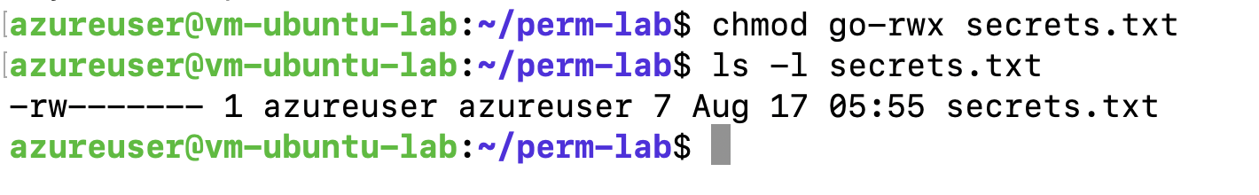
Allow group members to write to reports directory:
chmod g+w reports
ls -ld reports
Expect something like: drwxrwxr-x (group now has w).
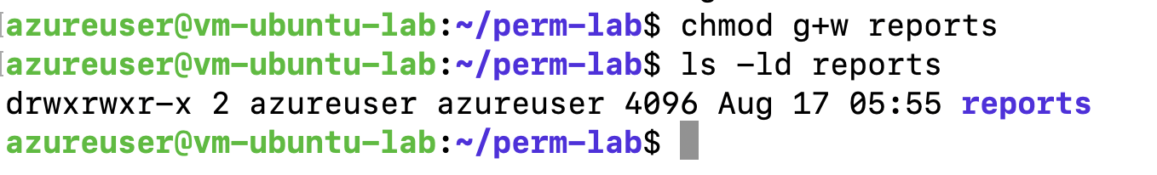
Make note.txt executable (just to see the effect):
chmod u+x note.txt
ls -l note.txt
Expect owner x: -rwxr--r--
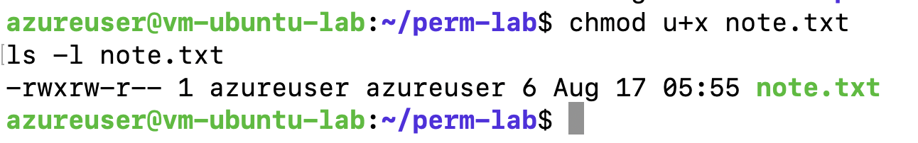

Part D — Change Permissions (Numeric/Octal Mode)
Numbers add up: r=4, w=2, x=1.
Examples: 7 (rwx), 6 (rw-), 5 (r-x), 4 (r--), 0 (---).
Set note.txt to 644 (rw-r--r--):
chmod 644 note.txt
ls -l note.txt

Set reports directory to 775 (rwxrwxr-x):
chmod 775 reports
ls -ld reports
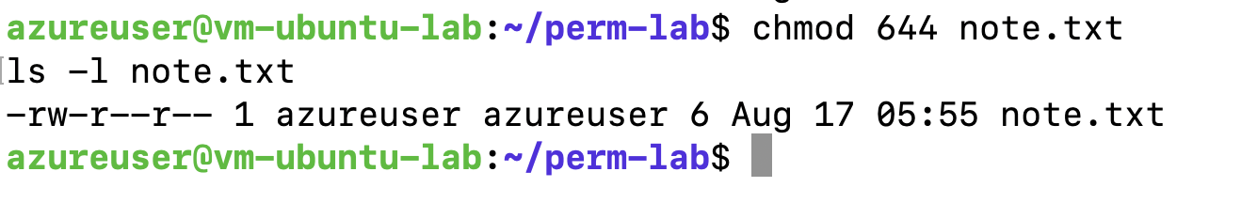
Typical patterns to remember:
- Files: 644 (owner can edit; everyone can read)
- Directories: 755 (owner full; others can enter & list)

Part E — Directory Execute Bit (Why x Matters on Folders)
Remove execute from data for others:
chmod o-x data
ls -ld data
Others (o) can now see data exists (if r is set) but cannot enter it (cd data) without x.
ls data
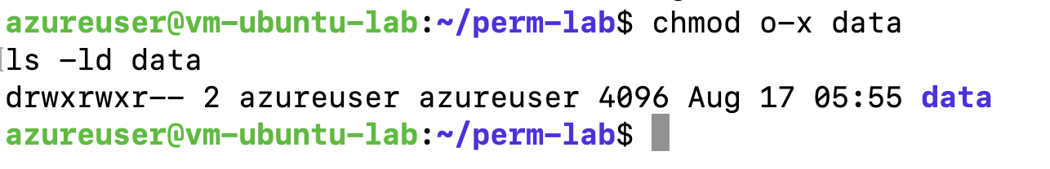
You (owner) still have x, so you can list. Another user without x couldn’t cd into it.
Rule of thumb: For directories, x is the “you may enter” door pass.

